**Answer to the Question no. – 1(di)**

**Google Colab Code:** Source code file has also attached(Name: *HomeWork2_Question1(di).ipynb*

|  |  |
| --- | --- |
| import numpy as np  import matplotlib.pyplot as plt  from sympy import symbols, lambdify  from mpl_toolkits.mplot3d import Axes3D  # Variables for coefficients  coef1_sym = symbols('coef1')  coef2_sym = symbols('coef2')  coef3_sym = symbols('coef3')  coef4_sym = symbols('coef4')  coef5_sym = symbols('coef5')  coef6_sym = symbols('coef6')  coef7_sym = symbols('coef7')  coef8_sym = symbols('coef8')  # Basis matrix  t = 10  basis_matrix = np.array([[1, 0, 0, 0, 0, 0, 0, 0],  [0, 1, 0, 0, 0, 0, 0, 0],  [0, 0, 0, 0, 1, 0, 0, 0],  [0, 0, 0, 0, 0, 1, 0, 0],  [1, t, t**2, t**3, 0, 0, 0, 0],  [0, 1, 2 * t, 3 * t**2, 0, 0, 0, 0],  [0, 0, 0, 0, 1, t, t**2, t**3],  [0, 0, 0, 0, 0, 1, 2 * t, 3 * t**2]])  print(basis_matrix)  # Matrix multiplication using pseudo-inverse  arr = np.array([[1],  [1],  [0],  [1],  [5],  [1],  [5],  [5]])  mul = np.linalg.pinv(basis_matrix)  solutions = np.dot(mul, arr)  print(solutions)  # Coefficients as dictionary  coefficients_dict = {  coef1_sym: solutions[0, 0],  coef2_sym: solutions[1, 0],  coef3_sym: solutions[2, 0],  coef4_sym: solutions[3, 0],  coef5_sym: solutions[4, 0],  coef6_sym: solutions[5, 0],  coef7_sym: solutions[6, 0],  coef8_sym: solutions[7, 0]  }  # alpha values as a list  alpha_values = [1.0000000e+00, 1.0000000e+00, -1.8000000e-01, 1.2000000e-02,  -1.0185019e-13, 1.0000000e+00, -5.5000000e-01, 5.0000000e-02]  # Generate t values  T = np.linspace(0, 10, 100)  # Functions of z1_dot & z2_dot  def z1_dot(T):  return alpha_values[1] + 2 * alpha_values[2] * T + 3 * alpha_values[3] * (T ** 2)  def z2_dot(T):  return alpha_values[5] + 2 * alpha_values[6] * T + 3 * alpha_values[7] * (T ** 2)  # Value of X2  x1 = z1_dot(T)  x3 = z2_dot(T)  def x2(T):  return x3 / x1  X2 = x2(T)  # Values of X1 & X3  X1 = alpha_values[0] + alpha_values[1] * T + alpha_values[2] * (T ** 2) + alpha_values[3] * (T ** 3)  X3 = alpha_values[4] + alpha_values[5] * T + alpha_values[6] * (T ** 2) + alpha_values[7] * (T ** 3)  # 3D plot  fig = plt.figure()  ax = fig.add_subplot(111, projection='3d')  ax.plot(X1, X2, X3, label='Trajectory')  ax.set_xlabel('X1')  ax.set_ylabel('X2')  ax.set_zlabel('X3')  ax.set_title('Trajectory in the 3D space')  ax.legend()  plt.show() |  |
|  |  |

**Output:**

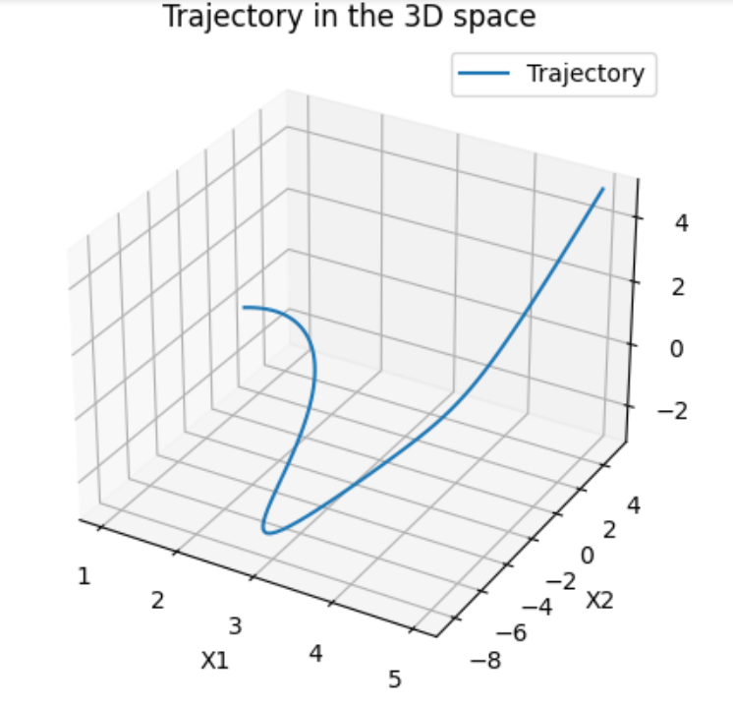

**Answer to the Question no. – 1(dii)**

**Google Colab Code:** Source code file has also attached(Name: *HomeWork2_Question1(dii).ipynb*)

|  |  |
| --- | --- |
| import numpy as np  import matplotlib.pyplot as plt  from sympy import symbols, lambdify  from mpl_toolkits.mplot3d import Axes3D  # Variables for coefficients  coef1_sym = symbols('coef1')  coef2_sym = symbols('coef2')  coef3_sym = symbols('coef3')  coef4_sym = symbols('coef4')  coef5_sym = symbols('coef5')  coef6_sym = symbols('coef6')  coef7_sym = symbols('coef7')  coef8_sym = symbols('coef8')  # Basis matrix  t = 15  basis_matrix = np.array([[1, 0, 0, 0, 0, 0, 0, 0],  [0, 1, 0, 0, 0, 0, 0, 0],  [0, 0, 0, 0, 1, 0, 0, 0],  [0, 0, 0, 0, 0, 1, 0, 0],  [1, t, t**2, t**3, 0, 0, 0, 0],  [0, 1, 2 * t, 3 * t**2, 0, 0, 0, 0],  [0, 0, 0, 0, 1, t, t**2, t**3],  [0, 0, 0, 0, 0, 1, 2 * t, 3 * t**2]])  print(basis_matrix)  # Matrix multiplication using pseudo-inverse  arr = np.array([[1],  [1],  [0],  [1],  [10],  [1],  [5],  [10]])  mul = np.linalg.pinv(basis_matrix)  solutions = np.dot(mul, arr)  print(solutions)  # Coefficients as dictionary  coefficients_dict = {  coef1_sym: solutions[0, 0],  coef2_sym: solutions[1, 0],  coef3_sym: solutions[2, 0],  coef4_sym: solutions[3, 0],  coef5_sym: solutions[4, 0],  coef6_sym: solutions[5, 0],  coef7_sym: solutions[6, 0],  coef8_sym: solutions[7, 0]  }  # alpha values as a list  alpha_values = [1.00000000e+00, 1.00000000e+00, -8.00000000e-02, 3.55555556e-03,  4.14285794e-13, 1.00000000e+00, -7.33333333e-01, 4.59259259e-02]  # Generate t values  T = np.linspace(0, 15, 100)  # Functions of z1_dot & z2_dot  def z1_dot(T):  return alpha_values[1] + 2 * alpha_values[2] * T + 3 * alpha_values[3] * (T ** 2)  def z2_dot(T):  return alpha_values[5] + 2 * alpha_values[6] * T + 3 * alpha_values[7] * (T ** 2)  # Value of X2  x1 = z1_dot(T)  x3 = z2_dot(T)  def x2(T):  return x3 / x1  X2 = x2(T)  # Values of X1 & X3  X1 = alpha_values[0] + alpha_values[1] * T + alpha_values[2] * (T ** 2) + alpha_values[3] * (T ** 3)  X3 = alpha_values[4] + alpha_values[5] * T + alpha_values[6] * (T ** 2) + alpha_values[7] * (T ** 3)  # 3D plot  fig = plt.figure()  ax = fig.add_subplot(111, projection='3d')  ax.plot(X1, X2, X3, label='Trajectory')  ax.set_xlabel('X1')  ax.set_ylabel('X2')  ax.set_zlabel('X3')  ax.set_title('Trajectory in the 3D space')  ax.legend()  plt.show() |  |

**Output:**

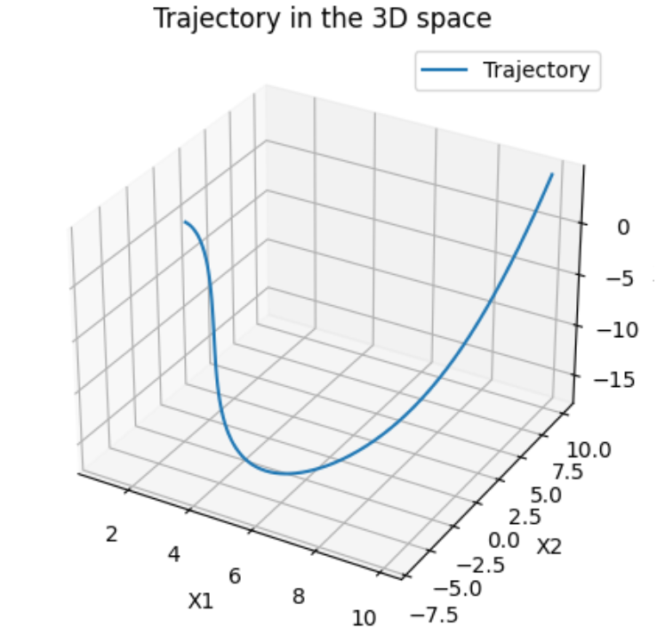

**Answer to the Question no. – 2(b)**

**Google Colab Code:** Source code file has also attached(Name: *HomeWork2_Question2(b).ipynb*

|  |  |
| --- | --- |
| import numpy as np  import matplotlib.pyplot as plt  from sympy import symbols, lambdify  # Variables for coefficients  coef1_sym = symbols('coef1')  coef2_sym = symbols('coef2')  coef3_sym = symbols('coef3')  coef4_sym = symbols('coef4')  coef5_sym = symbols('coef5')  coef6_sym = symbols('coef6')  coef7_sym = symbols('coef7')  coef8_sym = symbols('coef8')  # Basis matrix  t = 15  basis_matrix = np.array([[1, 0, 0, 0, 0, 0, 0, 0],  [0, 1, 0, 0, 0, 0, 0, 0],  [0, 0, 0, 0, 1, 0, 0, 0],  [0, 0, 0, 0, 0, 1, 0, 0],  [1, t, t**2, t**3, 0, 0, 0, 0],  [0, 1, 2 * t, 3 * t**2, 0, 0, 0, 0],  [0, 0, 0, 0, 1, t, t**2, t**3],  [0, 0, 0, 0, 0, 1, 2 * t, 3 * t**2]])  print(basis_matrix)  # Matrix multiplication using pseudo-inverse  arr = np.array([[0],  [0],  [0.5],  [-1.6],  [5],  [5],  [0.5],  [-1.6]])  mul = np.linalg.pinv(basis_matrix)  solutions = np.dot(mul, arr)  print(solutions)  # Coefficients as dictionary  coefficients_dict = {  coef1_sym: solutions[0, 0],  coef2_sym: solutions[1, 0],  coef3_sym: solutions[2, 0],  coef4_sym: solutions[3, 0],  coef5_sym: solutions[4, 0],  coef6_sym: solutions[5, 0],  coef7_sym: solutions[6, 0],  coef8_sym: solutions[7, 0]  }  # alpha values as a list  alpha_values = [1.00000000e+00, 1.00000000e+00, -8.00000000e-02, 3.55555556e-03,  4.14285794e-13, 1.00000000e+00, -7.33333333e-01, 4.59259259e-02]  # Generate T values  T = np.linspace(0, 15, 100)  # Values of X1 & X3  X1 = alpha_values[0] + alpha_values[1] * T + alpha_values[2] * (T ** 2) + alpha_values[3] * (T ** 3)  X3 = alpha_values[4] + alpha_values[5] * T + alpha_values[6] * (T ** 2) + alpha_values[7] * (T ** 3)  # plot  plt.figure()  plt.plot(X1, X3, label='Trajectory')  plt.xlabel('X')  plt.ylabel('Y')  plt.title('Trajectory of the unicycle robot')  plt.legend()  plt.grid(True)  plt.show() |  |

**Output:**

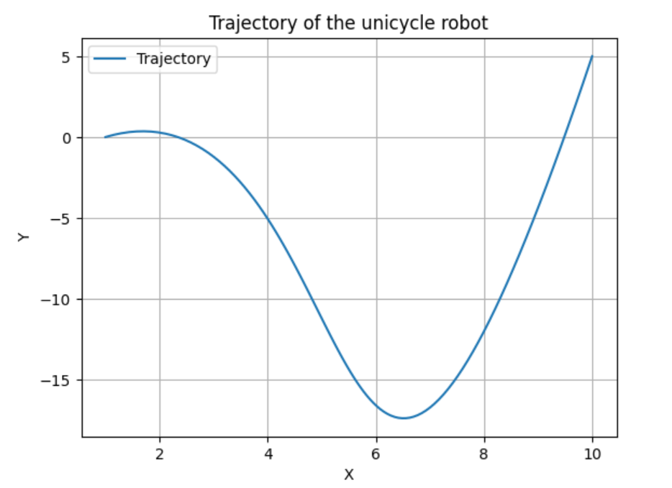

**Answer to the Question no. – 2(c)**

**Google Colab Code:** Source code file has also attached(Name: *HomeWork2_Question2(c).ipynb*

|  |  |
| --- | --- |
|  |  |
| import numpy as np  import matplotlib.pyplot as plt  # Time array  t = np.arange(0, 15, 0.01)  len(t)  # Final time T  T = 15  Tsq = np.power(T, 2)  Tcb = np.power(T, 3)  # Initialize matrix A  A = np.array([  [1, 0, 0, 0, 0, 0, 0, 0],  [0, 1, 0, 0, 0, 0, 0, 0],  [0, 0, 0, 0, 1, 0, 0, 0],  [0, 0, 0, 0, 0, 1, 0, 0],  [1, T, Tsq, Tcb, 0, 0, 0, 0],  [0, 1, 2*T, 3*Tsq, 0, 0, 0, 0],  [0, 0, 0, 0, 1, T, Tsq, Tcb],  [0, 0, 0, 0, 0, 1, 2*T, 3*Tsq]  ])  # Initialize vector b with initial and final conditions for position and velocity  b = np.array([  [0], # Initial position X  [0], # Initial velocity X  [0], # Initial position Y  [-0.5], # Initial velocity Y  [5], # Final position X  [0], # Final velocity X  [5], # Final position Y  [-0.5] # Final velocity Y  ])  # Calculate the pseudo-inverse of matrix A  A_inv = np.linalg.pinv(A)  # Calculate polynomial coefficients x = A_inv * b  x = np.matmul(A_inv, b)  # Extract polynomial coefficients  a11, a12, a13, a14 = x[0], x[1], x[2], x[3]  a21, a22, a23, a24 = x[4], x[5], x[6], x[7]  # Calculate the desired trajectory for X and Y coordinates  X_new = a11 + a12 * t + a13 * np.power(t, 2) + a14 * np.power(t, 3)  Y_new = a21 + a22 * t + a23 * np.power(t, 2) + a24 * np.power(t, 3)  # Calculate the second derivatives  Xdd = np.gradient(np.gradient(X_new, t), t)  Ydd = np.gradient(np.gradient(Y_new, t), t)  # Calculate the angle theta  theta = np.arctan2(np.gradient(Y_new, t), np.gradient(X_new, t))  # Calculate the speed  V = np.sqrt(np.gradient(X_new, t)**2 + np.gradient(Y_new, t)**2)  # Calculate the acceleration and angular velocity  a = np.cos(theta) * Xdd + np.sin(theta) * Ydd  omega = (-np.sin(theta) * Xdd + np.cos(theta) * Ydd) / V  # Initialize final states  x_final = X_new[0]  y_final = Y_new[0]  theta_final = theta[0]  V_final = V[0]  # Initialize lists to hold robot's states  x_states = [x_final]  y_states = [y_final]  # Calculate robot trajectory  for i in range(1, len(t)):  dt = t[i] - t[i - 1] # Calculate time step    # Update final states  x_final += V_final * np.cos(theta_final) * dt  y_final += V_final * np.sin(theta_final) * dt  theta_final += omega[i] * dt  V_final += a[i] * dt    # Append updated states to the lists  x_states.append(x_final)  y_states.append(y_final)  # Visualize the desired trajectory and robot trajectory  fig, (ax1, ax2) = plt.subplots(1, 2, figsize=(12, 5))  # Desired trajectory  ax1.plot(X_new, Y_new, label='Desired Trajectory', color='green')  ax1.set_xlabel('X')  ax1.set_ylabel('Y')  ax1.legend()  ax1.set_title('Desired Trajectory')  ax1.grid(True)  # Robot trajectory  ax2.plot(x_states, y_states, label='Robot Trajectory', color='red')  ax2.set_xlabel('X')  ax2.set_ylabel('Y')  ax2.legend()  ax2.set_title('Robot Trajectory')  ax2.grid(True)  # plots  plt.tight_layout()  plt.show()  # Plot the desired and robot trajectories  plt.figure()  plt.plot(X_new, Y_new, label='Desired Trajectory', color='green')  plt.plot(x_states, y_states, label='Robot Trajectory', linestyle='dotted', color='red')  plt.xlabel('X')  plt.ylabel('Y')  plt.title('Desired and Robot Trajectories')  plt.legend()  plt.grid(True)  plt.show()  # Plot the desired and robot trajectories with additional properties  plt.figure()  plt.plot(X_new, Y_new, label='Desired Trajectory', color='green')  plt.plot(x_states, y_states, label='Robot Trajectory', linestyle='-',  linewidth=5, color='red', alpha=0.5, marker='o', markersize=1,  markeredgecolor='red')  plt.xlabel('X')  plt.ylabel('Y')  plt.legend()  plt.title('Desired and Robot Trajectories')  plt.grid(True)  plt.show() |  |

**Output:**

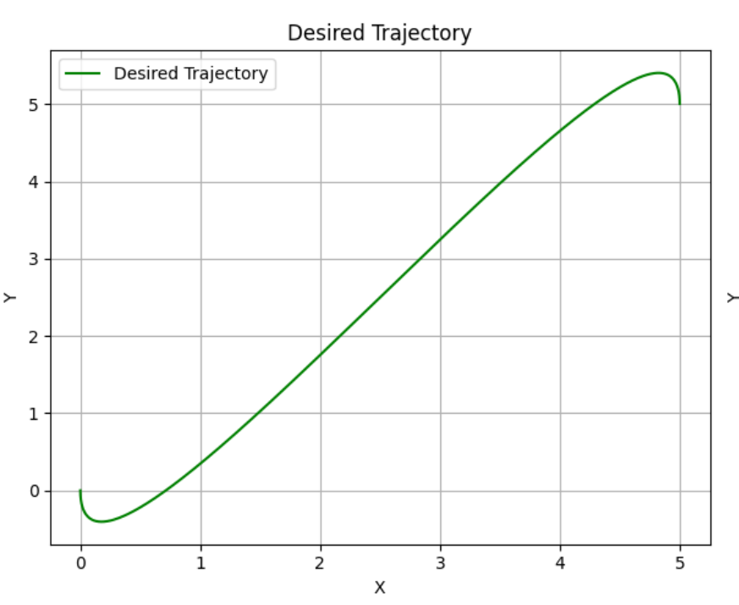

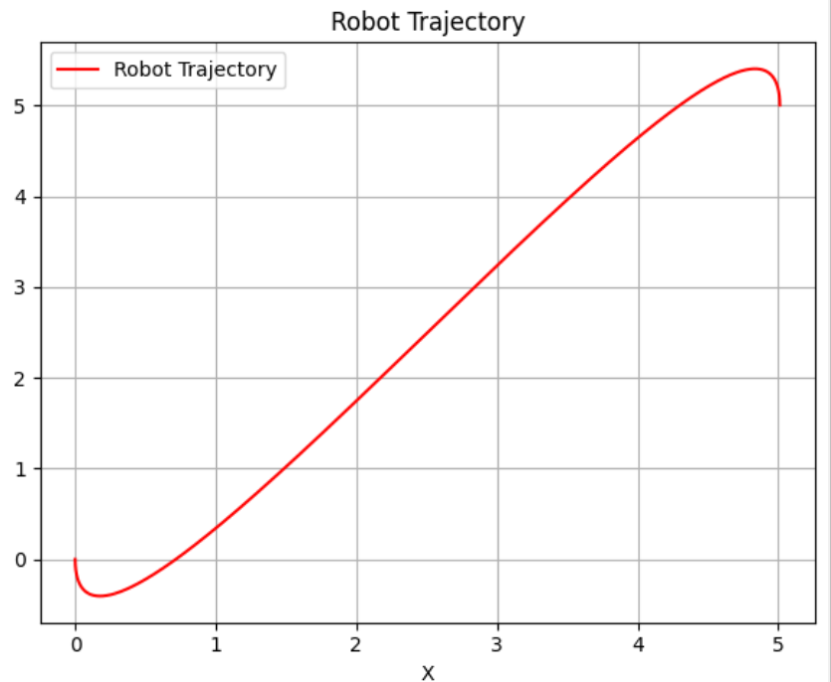

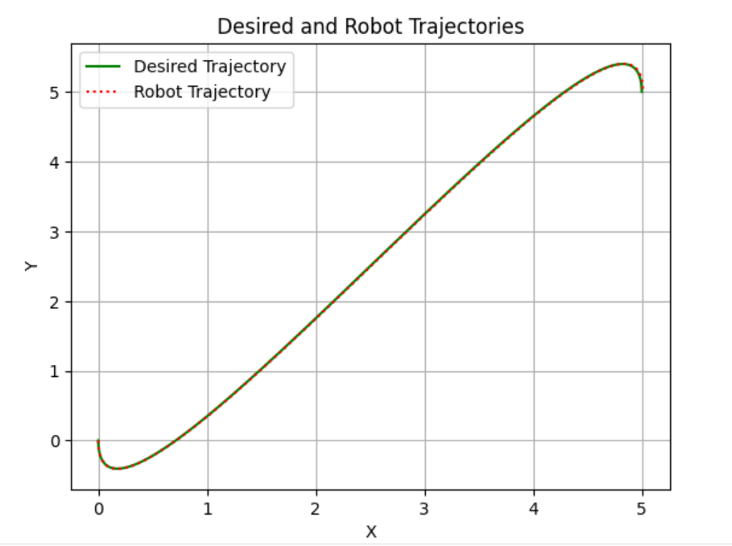

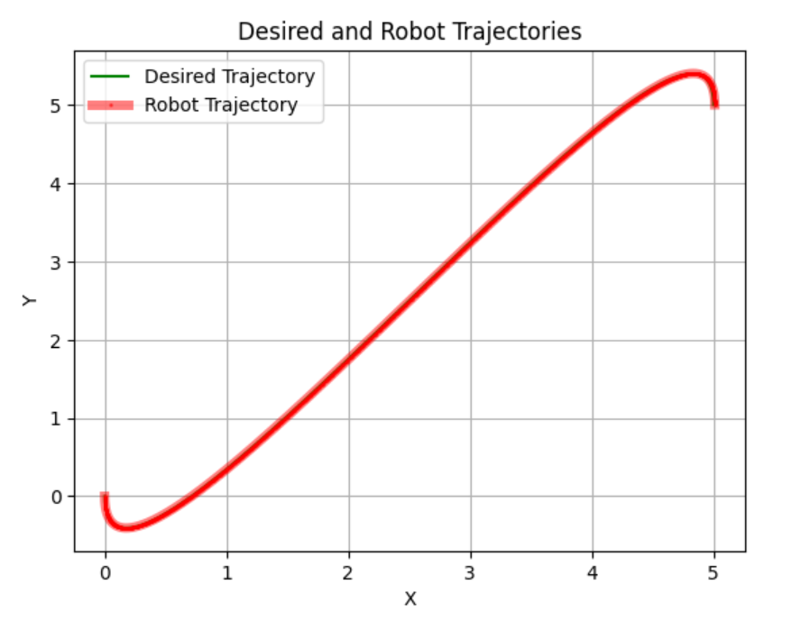

**Answer to the Question no. – 3**

**Google Colab Code:** Source code file has also attached(Name: *HomeWork2_Question3.ipynb*

|  |  |
| --- | --- |
| import numpy as np  import matplotlib.pyplot as plt  # Time variable  t = np.arange(0, 15, 0.01)  # Desired trajectory  T = 15  Tsq = T**2  Tcb = T**3  # Matrix A for calculating trajectory coefficients  A = np.array([  [1, 0, 0, 0, 0, 0, 0, 0],  [0, 1, 0, 0, 0, 0, 0, 0],  [0, 0, 0, 0, 1, 0, 0, 0],  [0, 0, 0, 0, 0, 1, 0, 0],  [1, T, Tsq, Tcb, 0, 0, 0, 0],  [0, 1, 2*T, 3*Tsq, 0, 0, 0, 0],  [0, 0, 0, 0, 1, T, Tsq, Tcb],  [0, 0, 0, 0, 0, 1, 2*T, 3*Tsq]  ])  # Vector b for calculating trajectory coefficients  b = np.array([  [0],  [0],  [0],  [-0.5],  [5],  [0],  [5],  [-0.5]  ])  # Calculate pseudo inverse of A  A_inv = np.linalg.pinv(A)  # Calculate x  x = np.matmul(A_inv, b)  # Extract coefficients from x  a11, a12, a13, a14 = x[:4]  a21, a22, a23, a24 = x[4:8]  # Calculate trajectories X and Y  X = a11 + a12 * t + a13 * t**2 + a14 * t**3  Y = a21 + a22 * t + a23 * t**2 + a24 * t**3  # Calculate gradients and other derived values  dX = np.gradient(X, t)  dY = np.gradient(Y, t)  theta = np.arctan2(dY, dX)  V = np.sqrt(dX**2 + dY**2)  a = np.cos(theta) * np.gradient(dX, t) + np.sin(theta) * np.gradient(dY, t)  omega = (-np.sin(theta) * np.gradient(dX, t) + np.cos(theta) * np.gradient(dY, t)) / V  # Noise levels for velocity and angle  noise_std_v = 0.01  noise_std_theta = 0.001  # Generate noise  noise_v = np.random.normal(0, noise_std_v, len(t))  noise_theta = np.random.normal(0, noise_std_theta, len(t))  # Initialize state variables  x_final = X[0]  y_final = Y[0]  theta_final = theta[0]  V_final = V[0]  # Lists to store robot trajectory states  x_states = [x_final]  y_states = [y_final]  # Calculate robot trajectory  for i in range(1, len(t)):  dt = t[i] - t[i - 1]  x_final += V_final * np.cos(theta_final) * dt  y_final += V_final * np.sin(theta_final) * dt  theta_final += omega[i] * dt + noise_theta[i]  V_final += a[i] * dt + noise_v[i]  x_states.append(x_final)  y_states.append(y_final)  # Plot X vs Y  plt.figure()  plt.plot(X, Y)  plt.title('X vs Y')  plt.xlabel('X')  plt.ylabel('Y')  plt.grid(True)  # Plot desired and robot trajectories  plt.figure()  plt.plot(X, Y, label='Desired Trajectory', color='blue')  plt.plot(x_states, y_states, label='Robot Trajectory', linestyle='dotted', color='red')  plt.xlabel('X')  plt.ylabel('Y')  plt.legend()  plt.title('Desired and Robot Trajectories')  plt.grid(True)  plt.show()  # Plot desired and robot trajectories with additional properties  plt.figure()  plt.plot(X, Y, label='Desired Trajectory', color='blue')  plt.plot(x_states, y_states, label='Robot Trajectory', linestyle='-', linewidth=5, color='red', alpha=0.5, marker='o', markersize=1, markeredgecolor='red')  plt.xlabel('X')  plt.ylabel('Y')  plt.legend()  plt.title('Desired and Robot Trajectories')  plt.grid(True)  plt.show() |  |

**Output:**

